Milestone 2

Tyrese

Kea

Tinyiko

5 September 2024

Github link:

Mobile app wireframes

Home screen

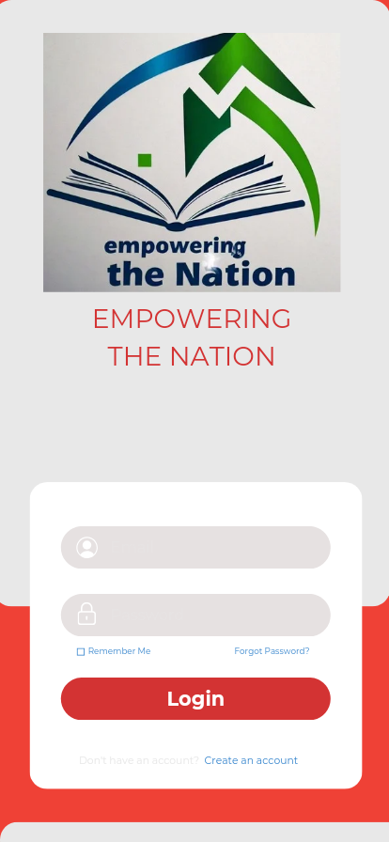

Login screen

3rd screen

Six week courses

Six week course details

Six months details

Six months course details

Academic calender

Calculate total cost

Financial aid

Faculty and stuff

News and events

Privacy policy

Student life

Student services

testimonials

Website wireframes

2nd screen

1st screen

3rd screen

4th screen

5th screen

